Renaming Documents

With Google Docs

- In the All Items list view, find the document to be renamed.

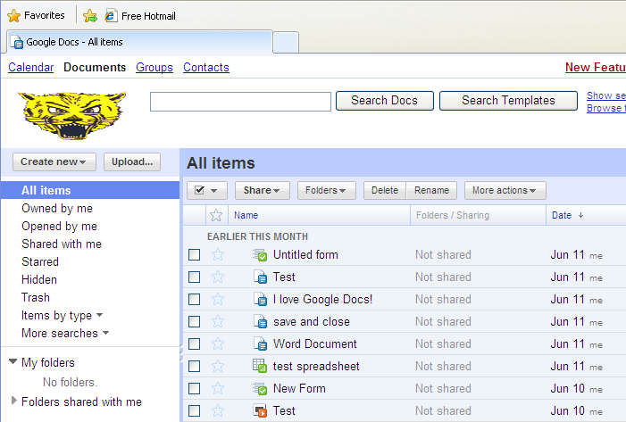

- Right click on the document, and select Rename.

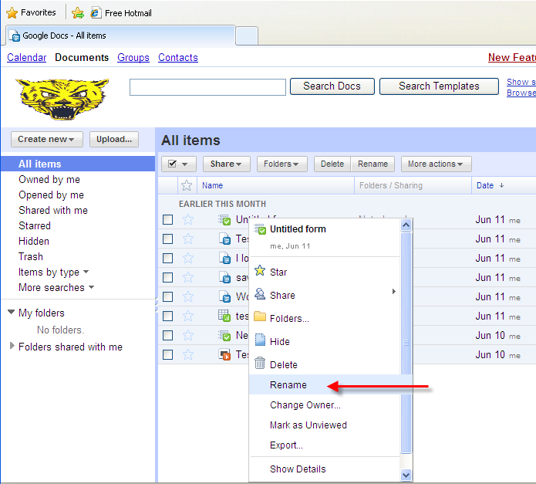

- Type the new document name and click Enter on the keyboard.

